KIN450 Neurophysiological Basis for Movement
Student’s Name
University

KIN450 Neurophysiological Basis for Movement
Question 1
Imagine that two groups of neurons (A & B) send their signals to another group of neurons (C). Action potentials generated simultaneously by all the neurons of group A lead to a response in C such that a select number of neurons in group C are activated (number of activated neurons =C₁);action potentials generated simultaneously by all the neurons of group B lead to a response in C such that C₂ is the number of activated neurons. What might the magnitude of the response be in C if action potentials were generated simultaneously by all the neurons in both A & B? Can it be bigger than, small than, or equal to (C₁ + C₂)? Why?
When there is a simultaneous generation of action potentials from both B and C, there will be an equal response, which is C₁ + C₂. Since neurons A activated a selected number of neurons which are C1 they will do the same, and the same case will apply to the neurons that are activated by neurons B. The group A and group B neurons are seen to be specific by activating a specific number of neurons namely C₁ and C₂ respectively. There will be no greater response to action potential than normal because action potentials are none or all. When the threshold is reached which is -55 mV depolarization will occur until a peak of +30 mV including the hyperpolarization (Trenor et al., 2017). There is the same peak; hence, there cannot be a bigger action potential as compared to the other. The specificity of the neurons makes them to cause response to specific number of cells for this case, group A cannot affect C2 neurons and the same case is true for the group B neurons as they cannot affect the C1 neurons. Therefore, each group of neurons will affect its own neurons without interfering with other. The response of neuron C will be cumulative action of C1 and C2.
Question 2
You place an electrode to a group of identical fibers in a dorsal root of the spinal cord. When you stimulate the fibers, in response to a single impulse you get a transient increase in the activity of a flexor muscle and a decrease in the activity of an extensor muscle at the same point. When you flex the joint with an external force, you see an increase in the activity of these fibers. When you stimulate γ-motoneurons innervating the extensor muscle, there are no changes in the activity of these fibers. Where do these fibers originate? On what basis did you arrive at your conclusion? Provide a drawing or schematic to accompany your answer.
The fibers originate from the gray matter of the spinal cords and leaves through the dorsal root. After originating from the dorsal root, it goes to the quadriceps muscles of the legs. These are the extensors of the leg rather than of the arm since those of the arm originate from the ventral root (Aboodarda et al., 2015). When there is stimulation of the fiber, the extensor muscles relax causing a decrease in its activity while the flexor muscles contracted, causing an increase in the activity. Flexing the joint with an external force causes the flexor muscle to contract and the extensor muscle to relax causing the increase in activity. There was no change in the activity of the fibers when the γ-motoneurons were stimulated because they are not directly involved in the shortening or lengthening of the muscles (Aboodarda et al., 2015). Nonetheless, the gamma motor neurons are vital through ensuring that the muscle spindles are taunted for the alpha neurons to continue firing which causes the muscle to contract. The figure below shows the differences in these muscles;
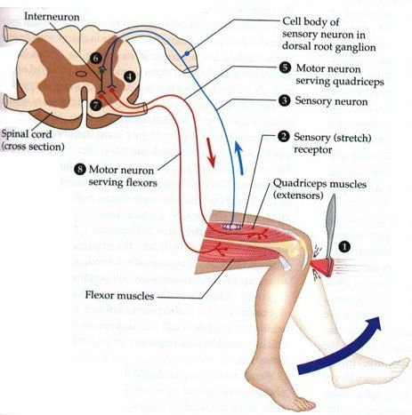
Figure 1: the figure shows the origin of the fiber from the dorsal root ganglion to the extensor muscles of the leg (quadriceps muscles)
In case of the arm the muscle comes from the ventral root as shown in the figure below;
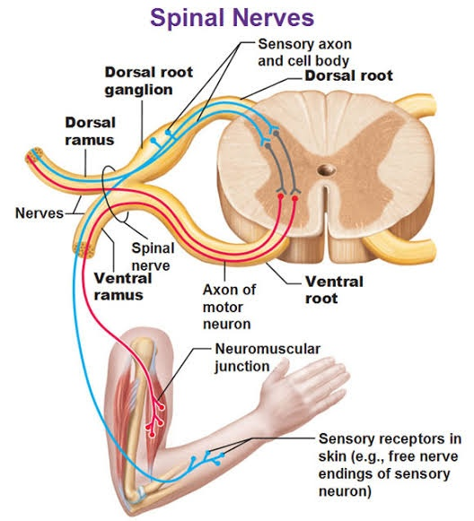
Figure 2: The figure above shows that the fibers for biceps(flexor) originates from the ventral root
Question 3
One dark night you and a friend take a walk to Gull pond. After getting to the beach, you look at the sky and spot the Big Dipper. Excited about seeing the constellation, you continue to look and gaze at the dark starry sky. After a short period of time, out of the corner of your eye, you see a new star. You shift your gaze to look at this star and it disappears. You’re confident that you’re looking in the right spot in the sky after all your head is still in the same extended position. Why has the star disappeared and how do know that your head is still looking up?
The disappearance of the star is due to the different anatomy of the photoreceptor of the retina. The eye has cones and rods, which are types of light-sensing cells. The cones are responsible for ensuring one can see color and fine details (Ingram, Sampath & Fain, 2016). On the other hand, the rods are for allowing better vision in the dim light. The cones are much concentrated at the center of the eye and the rods at the corners of the eyes. When focusing on the star (Big Dipper) the light falls at the center of the retina where there is much concentration of cones. The cones are critical in seeing in deem light. However, on the corner of the eyes, there are more rods that allow better visioning of the star (Ingram, Sampath & Fain, 2016). Therefore, the star which is seen on the corner eye is still the Big Dipper as it had disappeared from the cones. When shifting the head to look at the star one gets away from it making it seems as if it has disappeared.
Question 4
If someone tossed you a hot potato and you caught it, which information would reach your brain first; the news that the potato was hot, or that it was relatively smooth? Explain your answer. Describe the visual processing associated with catching the potato.
The information that will reach the brain first is that the potato is relatively smooth. Notably, this is because different receptors are used in mediating smoothness and temperature. In the case of smoothness, it is mediated by the cutaneous mechanoreceptor, which notes the touch sensations. The receptor has large axons that convey the sensation at a faster speed reaching up to 75 m/sec (Ran, Hoon & Chen, 2016). Alternatively, the temperature is mediated by the C fibers, which detect temperature and pain sensations. These fibers have smaller axon, which can be a diameter of less than 1 µm as well as lacking myelin. Therefore, they have a slow conduction of information at a speed of about 0.5-m/sec.
The special characteristics that cause the information to be spent faster is the diameter of the axon and the presence of myelin sheath. The large diameter is importance for increase in the conduction velocity and reduction of the resistance of flow of ions. The more space there is the more ions can travel and deliver the message in time. The large diameter of the axon reduces the chances of the ions bumping to other molecules. Since during the action potential some of the ions are lost across the membrane, the presence of myelin sheath prevents the ions from escaping through providing insulation.

References
Aboodarda, S. J., Copithorne, D. B., Power, K. E., Drinkwater, E., & Behm, D. G. (2015). Elbow flexor fatigue modulates central excitability of the knee extensors. Applied Physiology, Nutrition, and Metabolism, 40(9), 924-930.
Ingram, N. T., Sampath, A. P., & Fain, G. L. (2016). Why are rods more sensitive than cones?. The Journal of physiology, 594(19), 5415-5426.
Ran, C., Hoon, M. A., & Chen, X. (2016). The coding of cutaneous temperature in the spinal cord. Nature neuroscience, 19(9), 1201.
Trenor, B., Cardona, K., Saiz, J., Noble, D., & Giles, W. (2017). Cardiac action potential repolarization revisited: early repolarization shows all‐or‐none behaviour. The Journal of physiology, 595(21), 6599-6612.

